# Robotic Car Project Manual

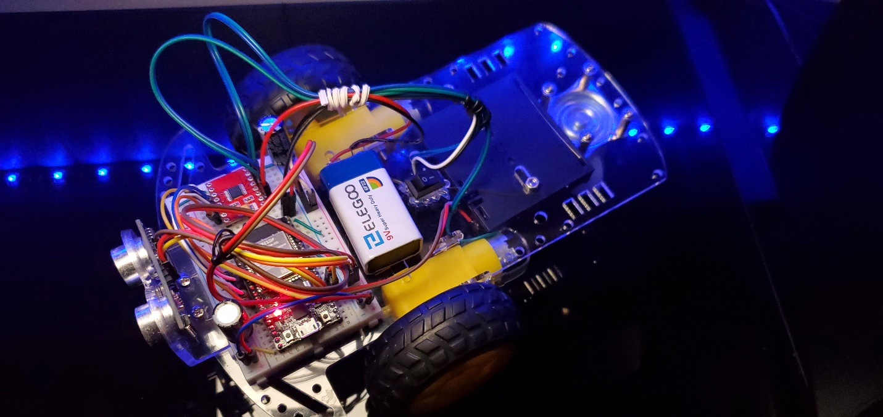

Contents

Robotic Car Project Manual 1

Alternative Subsytems 2

Alternative Wireless Communication Subsytems 2

Alternative Internet Communication Subsytems 2

Bill of material 3

System Description 4

System Operations 5

Testing Operations 6

## Alternative Subsytems

|  |  |  |  |
| --- | --- | --- | --- |
| Alternative Subsystems | | | |
| Requirement | Alternative 1 | Alternative 2 | Alternative 3 |
| Move forward at a certain speed | Joystick (potentiometer) | Array of switches | Array of pushbuttons |
| Slow speed with high steering angle | 100% software monitoring | Position sensor | Array of switches |
| Obstacle Avoidance | Ultrasonic sensors | Video sensor | Light sensor |
| Power to Motors | Battery | DC Voltage Supply | Solar Panel |

## Alternative Wireless Communication Subsytems

|  |  |  |  |
| --- | --- | --- | --- |
| **Comparison Item** | **PAN4620** Bluetooth LE v4.2 | **ESP-WROOM-S2**  Wi-Fi Module (802.11) | **Zigbee**  **MC13234CHT** |
| Price | $11.76 | $3.20 | $5.43 |
| Implementation | I2C,SPI,UART | SPI,UART,I2C,  GPIO,ADC,  SDIO | I2C, SPI, UART |
| Data Rate | 1Mbps | 150Mbps | 250kbps |
| Security | AES-128 | WPA/WPA2/WPS | AES-128 |
| Latency | 30µs | 0.1µs | 20ms |
| Interference | -93dBm | -98dBm | -94dBm |

## Alternative Internet Communication Subsytems

|  |  |  |  |
| --- | --- | --- | --- |
| **Comparison Item** | **Cisco Meraki**  **MG21E (4GLTE)** | **Huawei 5G CPE Pro H112-372** | **Digi TransPort**  **WR11XT** |
| Price | $677.99 | $259 | $239.99 |
| Implementation | 4G LTE | 5G/4G | WWAN |
| Data Rate | 300MBps | 5.1Gbps | 21Mbps |
| Security | 2-Factor Authentication | Firewall | AES=256 |
| Latency | Unknown | Unknown | Unknown |
| Interference | N/A | N/A | N/A |

## Bill of material

## System Description

Figure 1 System Schematic

Figure 2 System Wiring Diagram

**The ECET365 Robotic car takes advantage of the Wi-Fi features of the ESP32S and its built-in PWM motor control capabilities. Using a separately power 9V battery and an AdaFruit DRV8833 as a dual H-Bridge motor driver, capable of delivering up to 1Amps of current, the robotic car has a sustained run time of approximately 90 minutes.**

**The robotic car does a great job of utilizing a switch case interrupt program with the HC-SR04 Ultrasonic sensor as an obstacle avoidance feature. It is designed to reduce speeds going into high speed turns and come to a complete stop within 4 inches of an obstacle.**

**The web server interface allows users to control the car via a local Wi-Fi connection. Via a secure IP address, multiple user can control the car using a web browser on their cellphones or computers. The car is upgradeable, users can add cameras or other sensors as desired.**

## sYSTEM OperATIONS

**The ECET365 Robotic car uses a Wi-Fi interface for its motor controls. The car has 16-speeds. 12-speeds in the forward direction; 4-speeds in reverse. The car in omni-directional and both motors can operate independently of each other. Therefore, making the car spin in a given direction faster can be automatically done by adjusting the PWM of the opposite motor in the other direction.**

Figure 3 Web Interface Controls

## Testing OperATIONS

1. **Establish an internet connnection by adding your Wi-Fi credential to the source code.**

Figure 4 Change Network Credentials

1. Upload sketch onto the ESP32S. Open a serial monitor to verify that the device as established a connection.

1. Copy/Paste the IP address provided by the serial monitor into the URL search window of your browser. If the computer and the robotic car are under the same network, the web controls (see Figure 3) should appear.
2. Testing the controls using the serial monitor give you as visual representation of the commands flowing through the network as well as witnessing the response from the car.
3. Pressing the “Forward” button without pressing “Go” sends PWM signals to the motor driver without enabling the motors. We should see the “Forward” command being sent to the serial monitor and PWM signals sent to the input of the driver.

Figure 5 Serial Monitor: Forward Motors Disabled

Figure 6 Scope: Forward Motors Disabled

1. Pressing “Go” to enable the motors, we should see the “Go” command sent to the serial monitor. As well as, the PWM output waveforms of the DRV8833 being sent to the DC motors.

Figure 7 Forward Motors Enabled@39.1% Duty Cycle

Figure 8 Forward Motors Enabled@62.5% Duty Cycle

1. Testing “Left” and “Right” functions are similar to step 6. However, the difference is that only one of the inputs is receiving the PWM signals. This either causes the non PWM wheel to stay still or to operate in reverse.

Figure 9 Serial Monitor: Left

Figure 10 Scope: Left W/Motors Enabled@39.1% Duty Cycle

1. The serial Monitor can be used to test the obstacle avoidance system. The robotic car is design to sense danger within 4 inches of an obstacle. The HC-SR04 sends out a 8-40kHz ping signals with the intent to calculate the echo of the return signal. Any reading less than 4 inches is read as zero, disabling the DC motors.

Figure 11 Serial Monitor: Pause Figure 12 Seral Monitor: Ultrasonic Sensor